YD-SL Series 3040-60120 Silent Shredder
Industry Solutions: Confidential Destruction + Packaging Printing
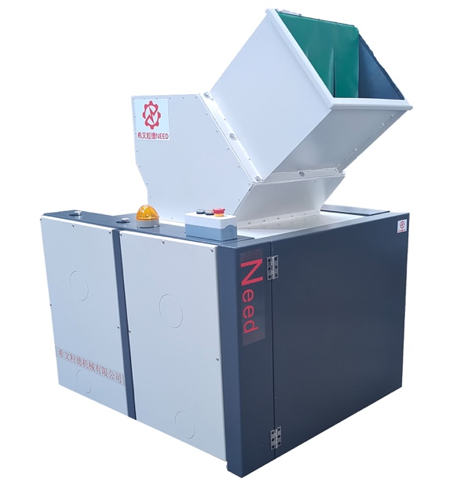 | 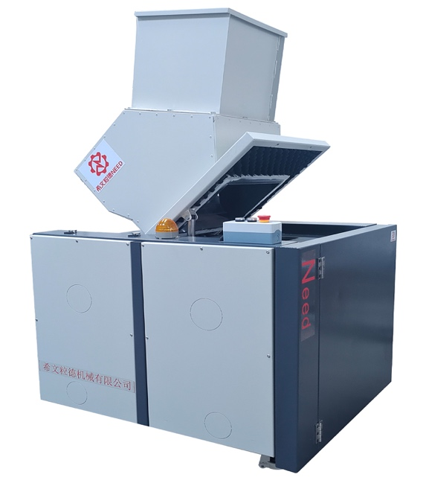 | 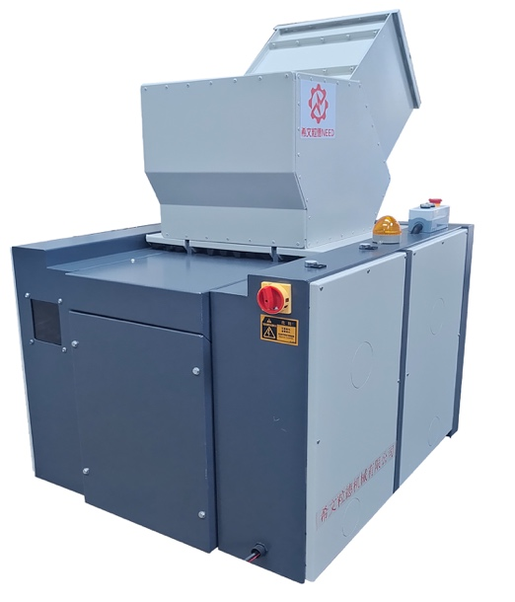 | 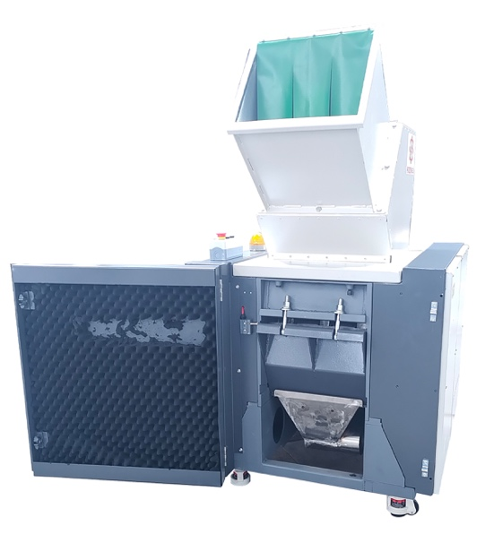
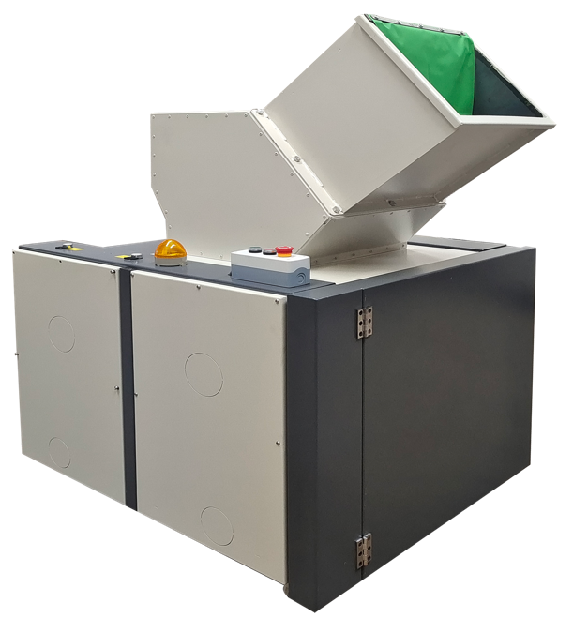 | 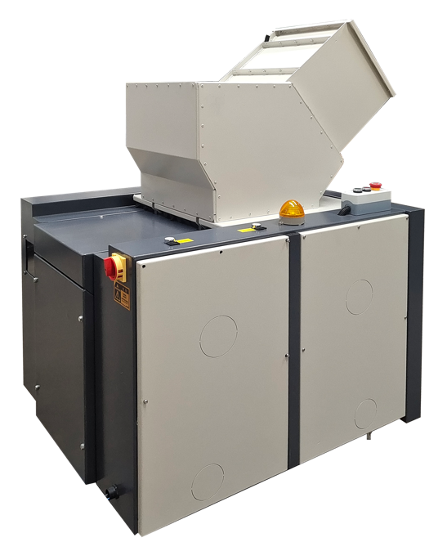 | 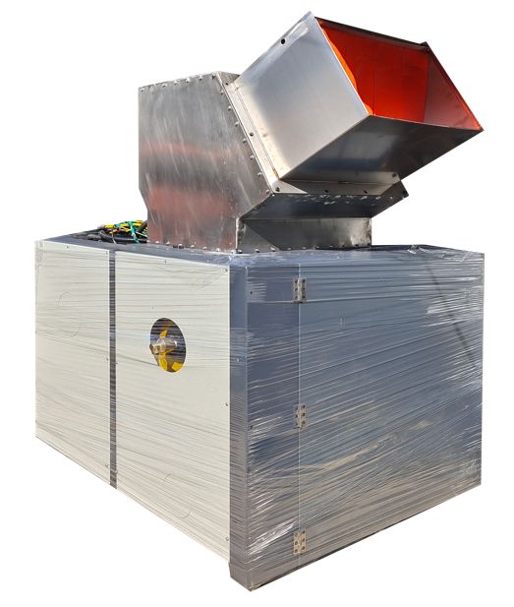 | 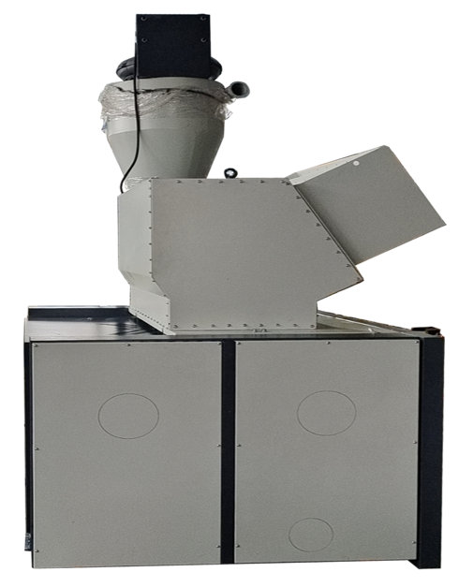
Designed with over 20 years of expertise, client application cases, and globally innovative technology, this unique new product features, but is not limited to:
- Exceptional Shredding for Confidential Materials: Shreds large and thick paper materials with minimal power requirements.
- Suitable for Ultra-Thick and Hard Products: Capable of handling tough materials with significantly increased productivity.
- Special Knife Box Design: High work efficiency with no material return.
- Low Noise: Significantly quieter than any similar models on the market, meeting environmental and ergonomic requirements reliably.
- Durable Bearing: No issues with dust clogging or damage; no leakage of material or dust from the box due to unique and reliable structure.
- Ideal for Low-Melting Plastics: Suitable for recycling plastic media such as film and cards with a reliable structure and high productivity.
- User-Friendly Design: Features a sleek appearance with no pull handles and one-touch operation.
- Remote Smart Control: Allows for remote intelligent operation and maintenance.
- Easy Maintenance: Pull-out screen and screen frame design for effortless and quick maintenance.
- Durable for Glass Fiber and Mineral Materials: Wear-resistant box with no fan wear issues and compact space.

Technical Specifications (for more, please consult sales for detailed information):
Product Model | YD-SL3040 | YD-SL4050 | YD-SL4060 | YD-SL4090 | YD-SL6080 | YD-SL60120
Inlet Dimensions (mm) | 320*420 | 400*520 | 400*600 | 400*900 | 620*800 | 620*1200
Feed Height | 1350 | 1700 | 1700 | 1600 | 2300 | 1600
Crushing Capacity (kg/h) | 100-200 | 500-600 | 600-800 | 1000-1200 | 1300-1500 | 2600-3000
Motor Power | 5.5KW, 380V | 22KW, 380V | 37KW, 380V | 37KW, 380V | 37KW, 380V | 55KW, 380V
Discharge (Customizable) | 8mm | 12mm | 12mm | 12mm | 12mm | 14mm
Product Dimensions (m) | 950*1120*1750 | 1788*1200*2100 | 1788*1200*2100 | 1850*1500*1810 | 2100*1800*3000 | 2000*2140*2000
Weight (kg) | 550KG | 1400KG | 1200KG | 1800KG | 2500KG | 7500KG
Product Price (including tax) | 9.7751万元 | 15.8571万元 | 18.9785万元 | 25.9071万元 | 34.8571万元 | 49.9715万元
Agent Price | 6.825万元 | 9.9735万元 | 12.8839万元 | 18.8304万元 | 25.7679万元 | 35.6785万元

YD-SL系列3040-60120型 静音型粉碎机 【行业解决方案：保密销毁 + 包装印刷】
二十年的设计，客户应用案例，以及全球新颖的技术核心，作为独创的新产品，有但不完全包括：
1）对于保密资料的剪切异常优异，大的厚的纸张材料只需要小功率即可实现粉碎。
2）对于超厚超硬产品也非常适合，而且产能明显提高。
3）刀箱特殊设计，工作效率高，不返料。
4）噪音明显低于市面上的任何同类机型，对于环保要求，人性化的要求客观可靠可信。
5）轴承永远不用担心粉尘卡死损坏，箱体永远没有漏料漏尘问题，独创结构可靠。
6）对于低熔点塑料介质（光片 卡片）回收非常适合，结构可靠，产能大。
7）机器外观无拉扣把手，一键式操作.
8）可实现远程智能控制操作维护。
9）筛网以及筛网架抽拉式装拆，省力快捷方便，维护轻松。
10）对于玻纤矿物材料的回收，箱体耐磨，无风机磨损问题，空间紧凑。

技术参数（其它机型，详询销售人员获取资料）：
产品型号 | YD-SL3040 | YD-SL4050 | YD-SL4060 | YD-SL4090 | YD-SL6080 | YD-SL60120
入口尺寸(mm) | 320*420 | 400*520 | 400*600 | 400*900 | 620*800 | 620*1200
投料口高度 | 1350 | 1700 | 1700 | 1600 | 2300 | 1600
粉碎能力（kg/h） | 100-200 | 500-600 | 600-800 | 1000-1200 | 1300-1500 | 2600-3000
电机功率 | 5.5KW, 380V | 22KW, 380V | 37KW, 380V | 37KW, 380V | 37KW, 380V | 55KW, 380V
出料（可定制） | 8mm | 12mm | 12mm | 12mm | 12mm | 14mm
产品尺寸（m） | 950*1120*1750 | 1788*1200*2100 | 1788*1200*2100 | 1850*1500*1810 | 2100*1800*3000 | 2000*2140*2000
重量（kg） | 550KG | 1400KG | 1200KG | 1800KG | 2500KG | 7500KG
产品售价（含税） | 9.7751万元 | 15.8571万元 | 18.9785万元 | 25.9071万元 | 34.8571万元 | 49.9715万元
代理价 | 6.825万元 | 9.9735万元 | 12.8839万元 | 18.8304万元 | 25.7679万元 | 35.6785万元


案例用户现场

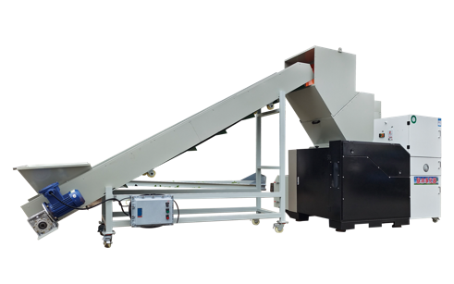 | 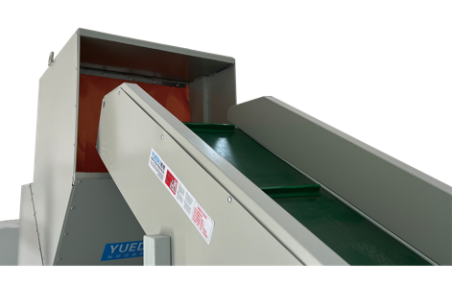 | 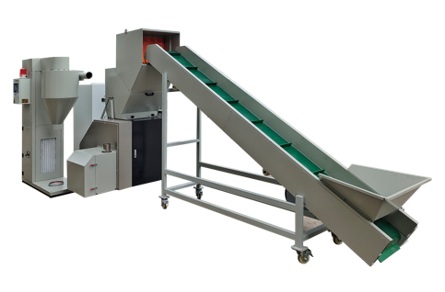

1级保密标准（1*2mm）

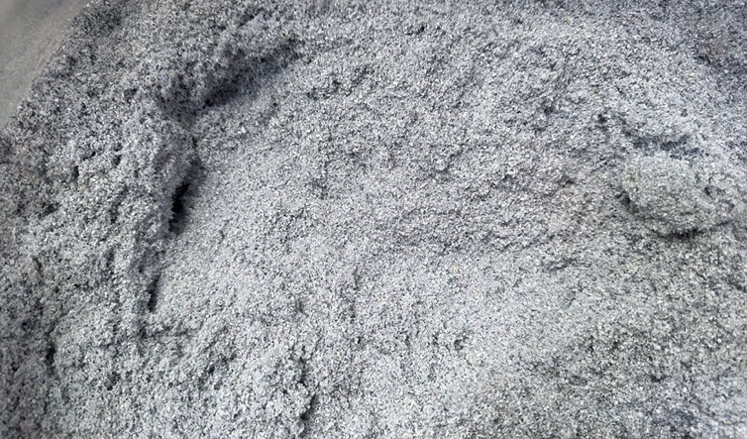 | 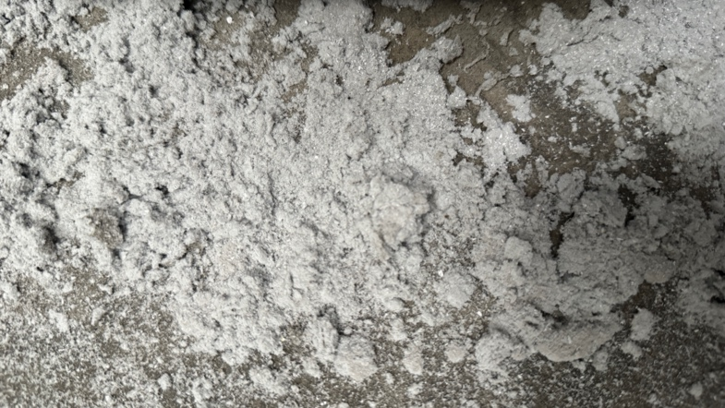
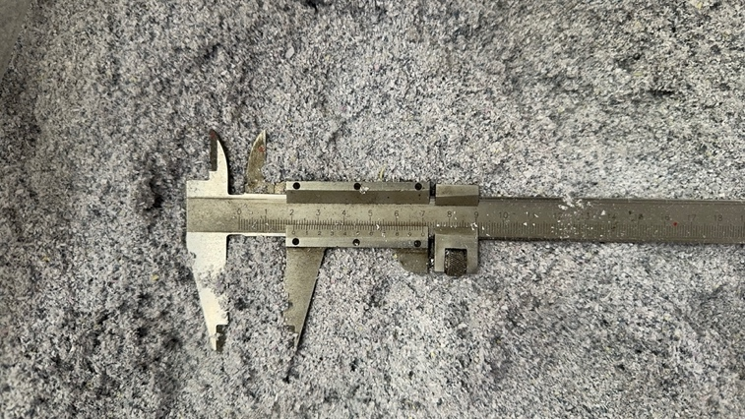 | 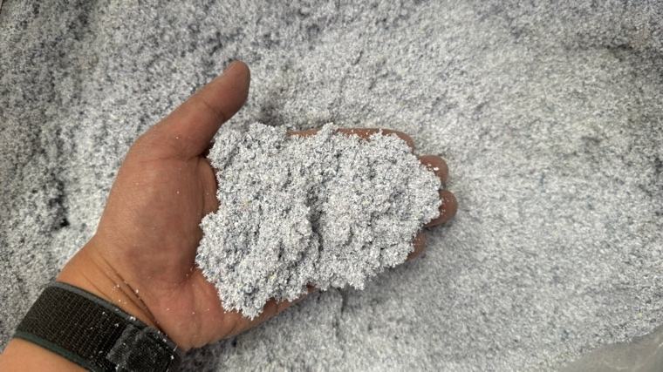

可碎整本凭证 和 标书

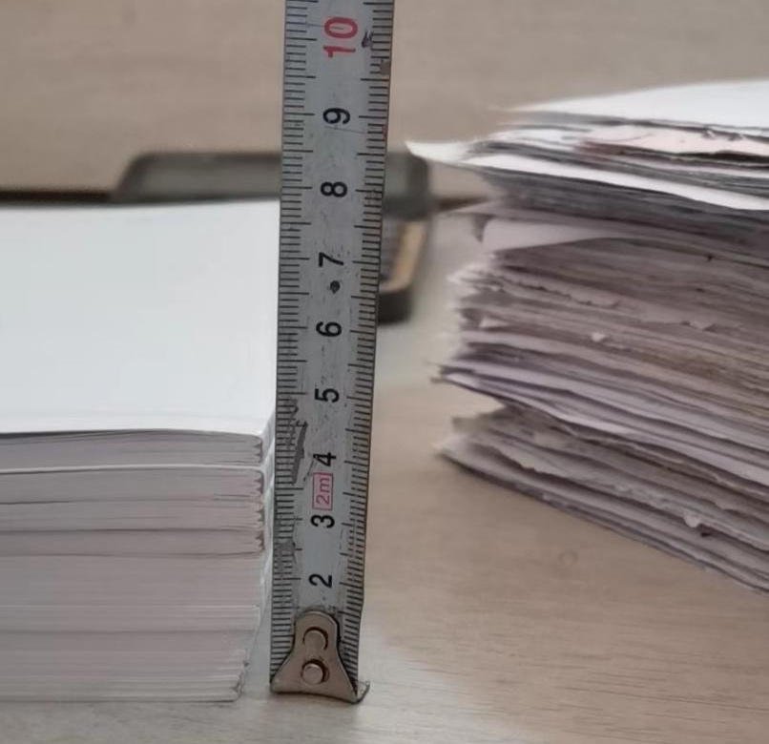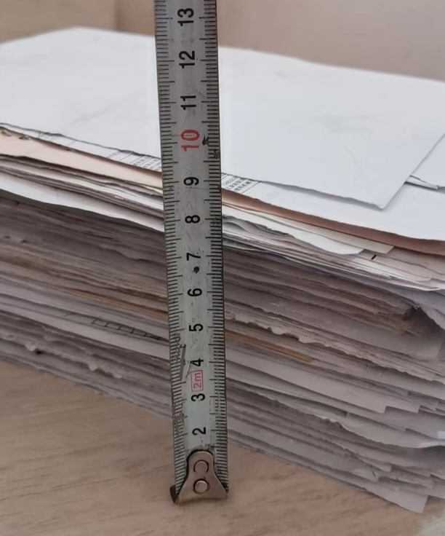

一次性可以丢入4-5CM厚度的标书文件和财务凭证
其它案例
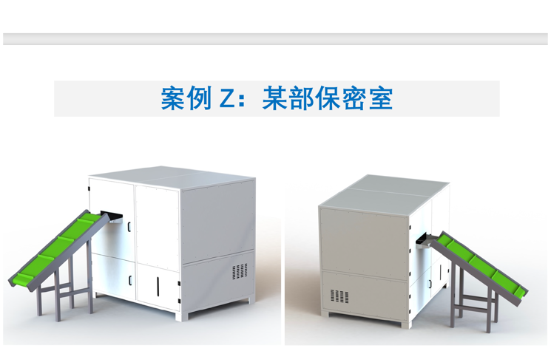 | 